**A PROJECT REPORT**

***Submitted by***

AKASH J.L 20203131522101

ASWIN S.J. KUMAR 20203131522102

ASHMI S.R 20203131522103

GEEVIS AJINS .S 20203131522104

IN PARTIAL FULFILLMENT FOR THE AWARD OF THE DEGREE

OF

BACHELOR OF SCIENCE

IN

PHYSICS



PIONEER KUMARASWAMY COLLEGE

NAGERCOIL-629 003

MANONMANIAM SUNDARANAR UNIVERSITY

TIRUNELVELI-627 012

APRIL-2023

**Introduction;**

***Overview***

## The growth of the global community has been significant over the past few decades due to various factors such as advancements in technology, increased international trade and travel, and the rise of social media. Advancements in technology, particularly in communication and transportation, have made it easier for people to connect and interact with each other from all corners of the world. With the internet and social media, people can now communicate and share information with others in real-time, regardless of their physical location. The growth of international trade has also played a significant role in bringing people and communities closer together. The ease of transportation and communication has made it possible for businesses to operate globally, creating job opportunities and economic growth in many regions. Moreover, the rise of social media platforms has allowed people to form connections and communities with individuals who share similar interests or values, regardless.

## *Purpose*

Understanding demographic trends: By analyzing population growth over time, researchers can identify patterns in demographic changes such as birth rates, death rates, and migration rates. This information can be used to make predictions about future population growth and to plan for future needs in areas such as healthcare, education, and housing.

Informing policy decisions: Population growth can have significant impacts on a country's economy, environment, and social fabric. Policymakers use population growth projections to make decisions about issues such as immigration, urban planning, and resource management.

Planning for resource allocation: Population growth can put strain on resources such as food, water, and energy. By calculating population growth, planners can anticipate future demands and develop strategies to ensure that resources are allocated efficiently.

Assessing the impact of interventions: Calculating population growth can help assess the effectiveness of interventions aimed at reducing population growth, such as family planning programs. By measuring changes in population growth over time, policymakers can evaluate the success of these programs and make adjustments as needed.

**Problem Definition and design thinking;**

***Empathy Map***

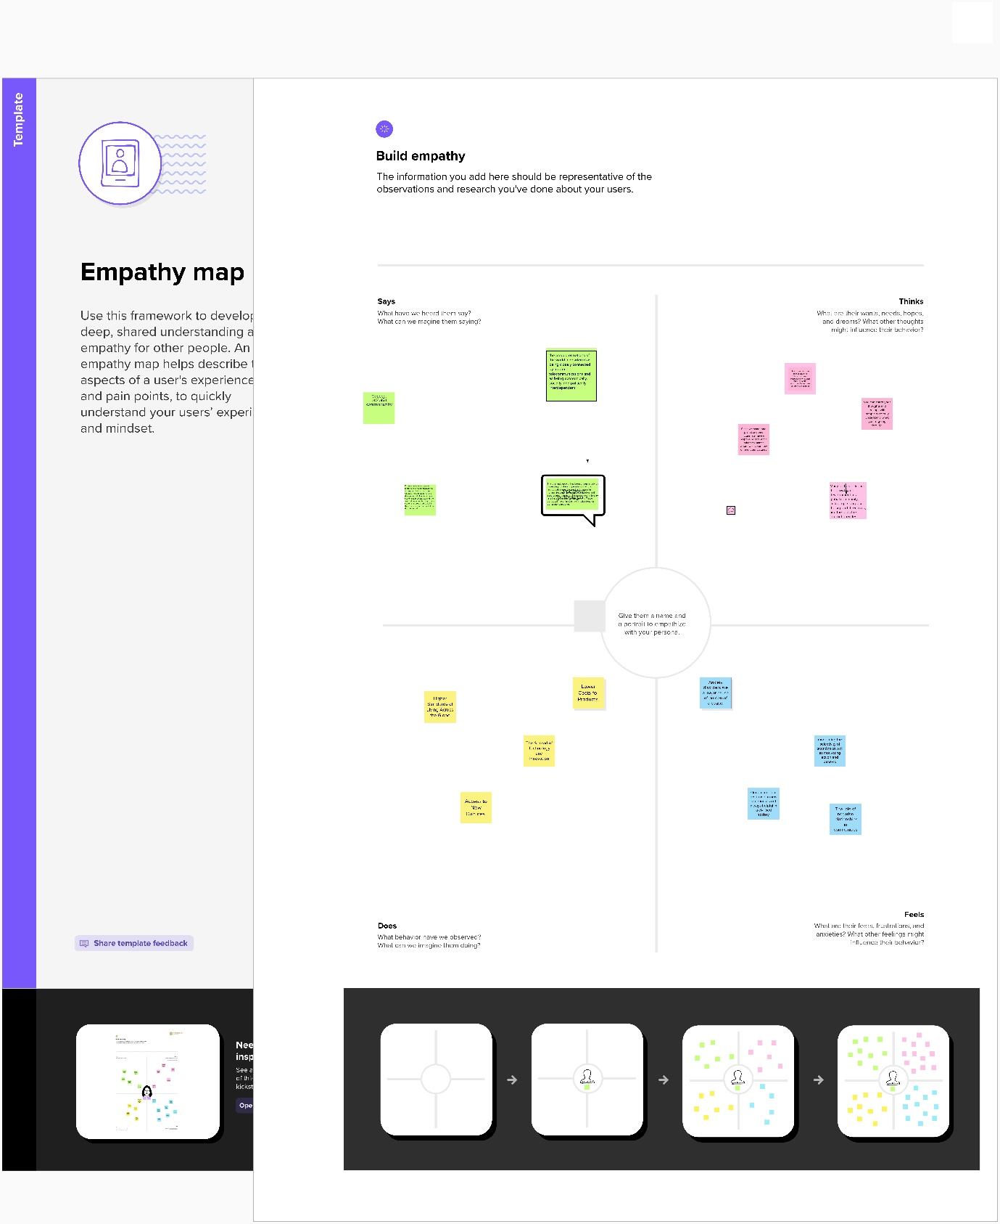

***Brainstorming Map:***

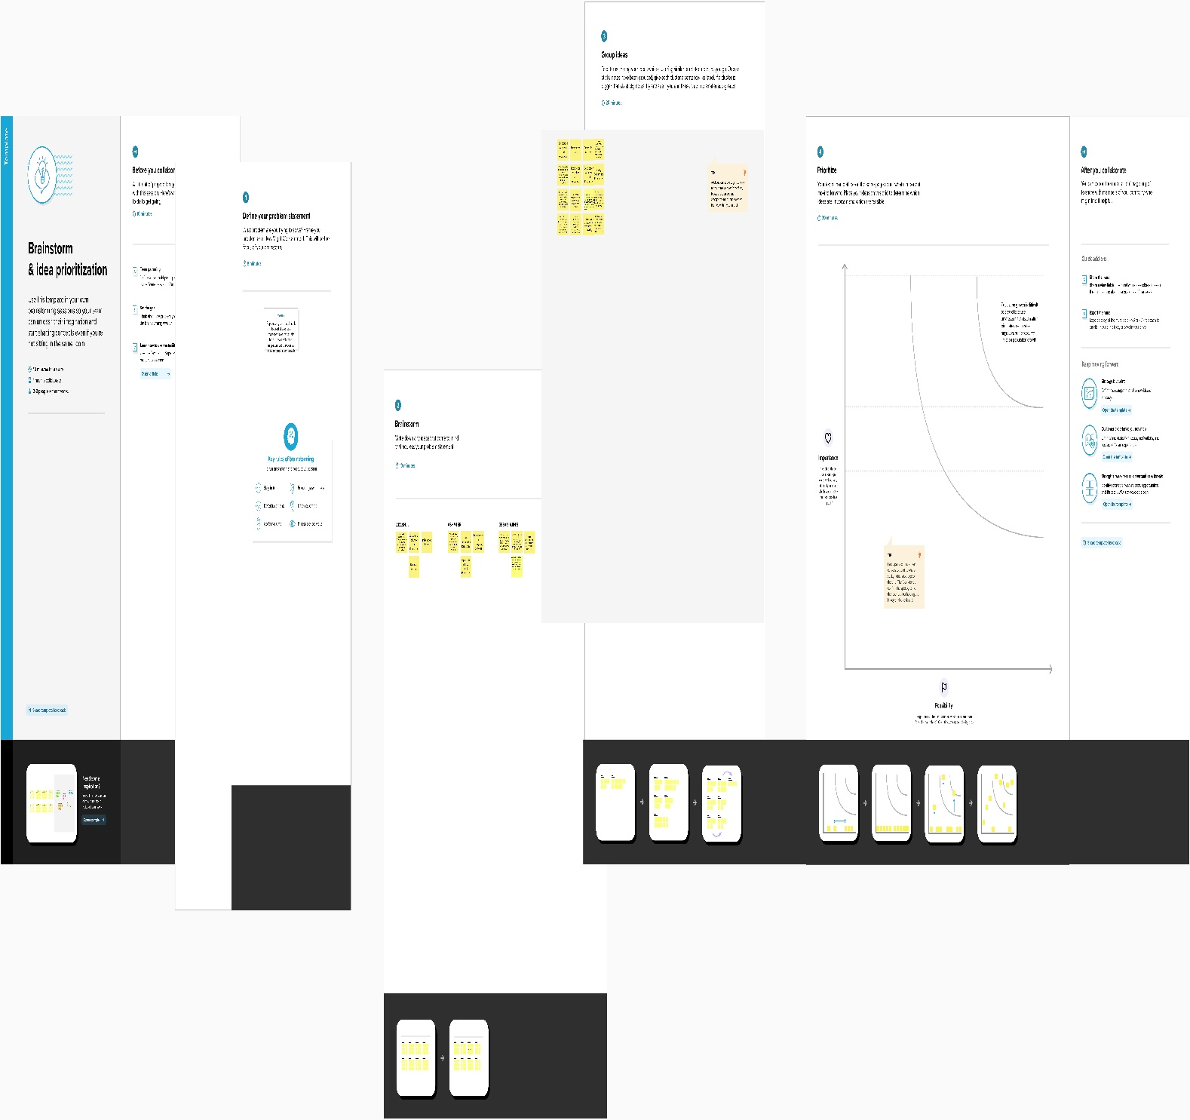

**Result**

***Data Model***

Object

Determine the starting year: Decide on a starting year from which you want to calculate the growth of the global community. For example, you could choose the year 1950, 2000, or any other year that you find relevant.

Find the population data: Use reliable sources to find the world population data for your chosen starting year and for the present year. The United Nations Population Division is a good source of population data.

Calculate the growth rate: To calculate the growth rate, subtract the population for the starting year from the population for the present year, and then divide the result by the population for the starting year. Multiply the result by 100 to get the percentage growth rate. The formula for growth rate is:

Growth rate = ((Present population - Starting population) / Starting population) * 100

Analyze the growth trend: Analyze the growth trend by comparing the growth rates for different time periods. You can use this information to predict future growth rates and make projections about the future global community.

It's important to note that calculating the growth of the global community is a complex task, and there are many factors that can impact population growth, such as birth rates, death rates, migration, and more. Therefore, it's important to use reliable data sources and take all relevant factors into account when making projections about population growth.

**Activity and Screenshots**

We discuss and calculate with My Tableau and our screen shots

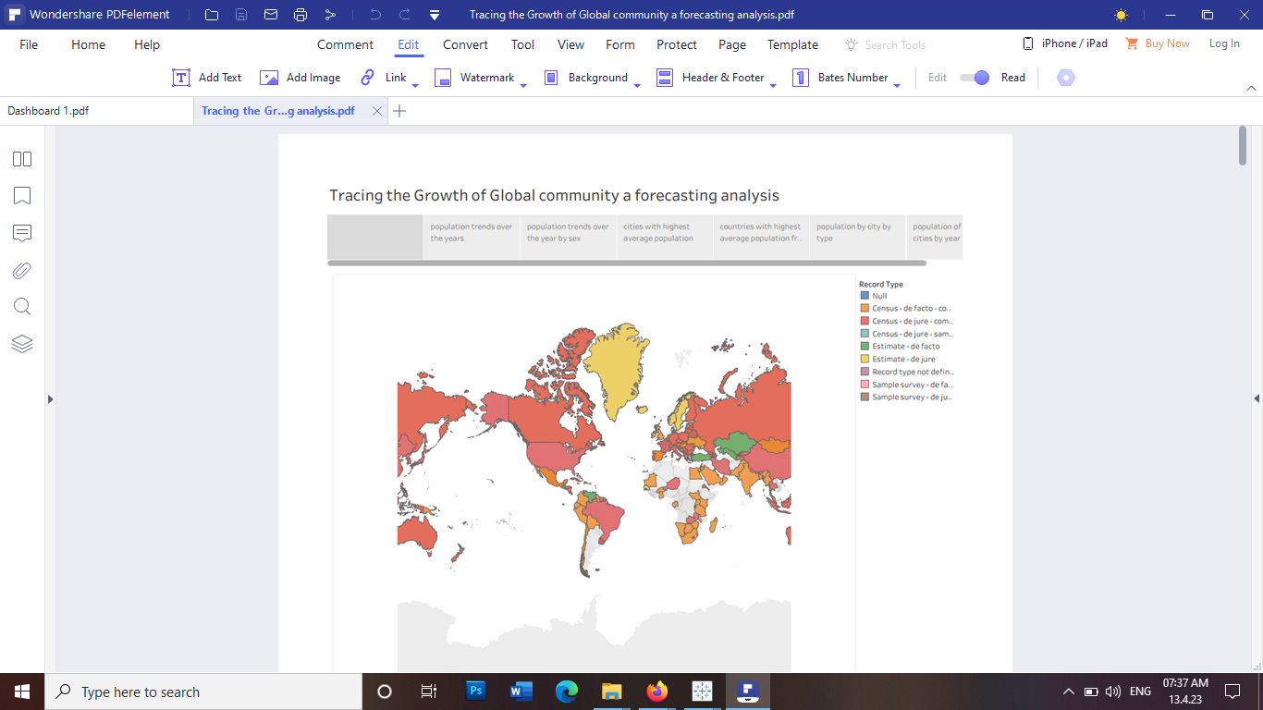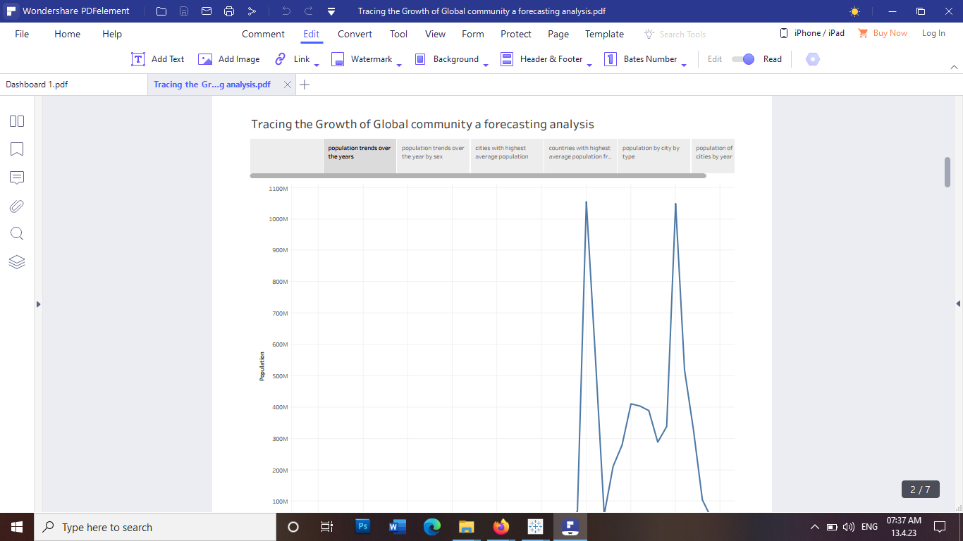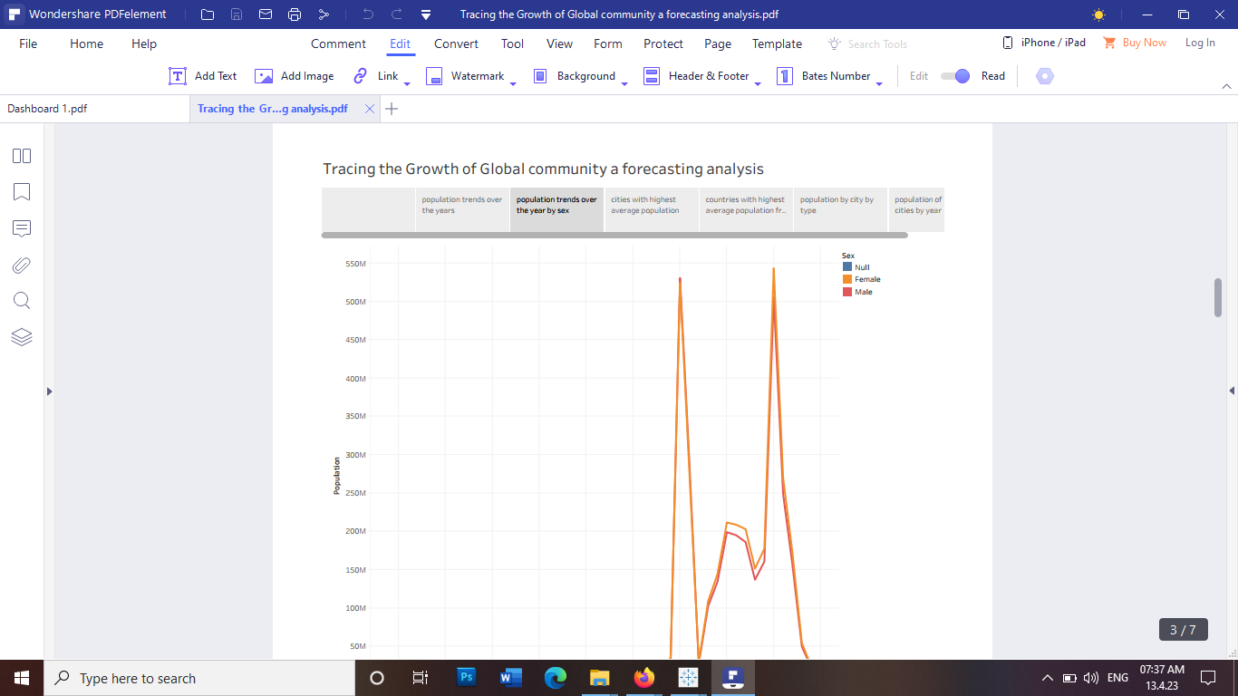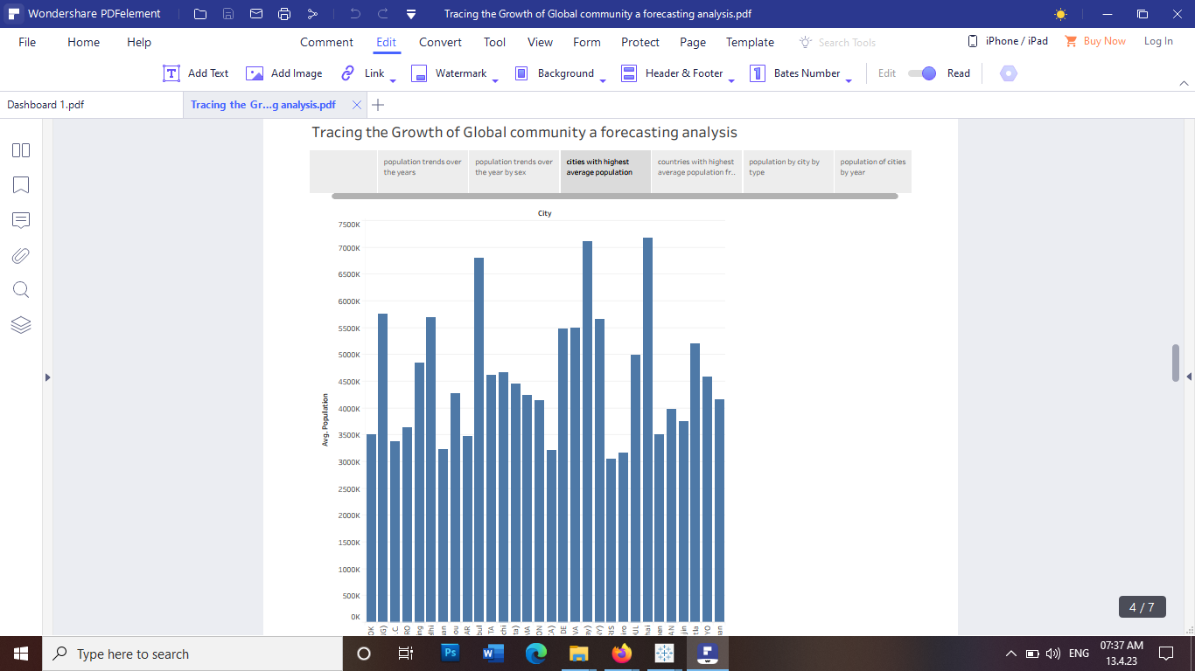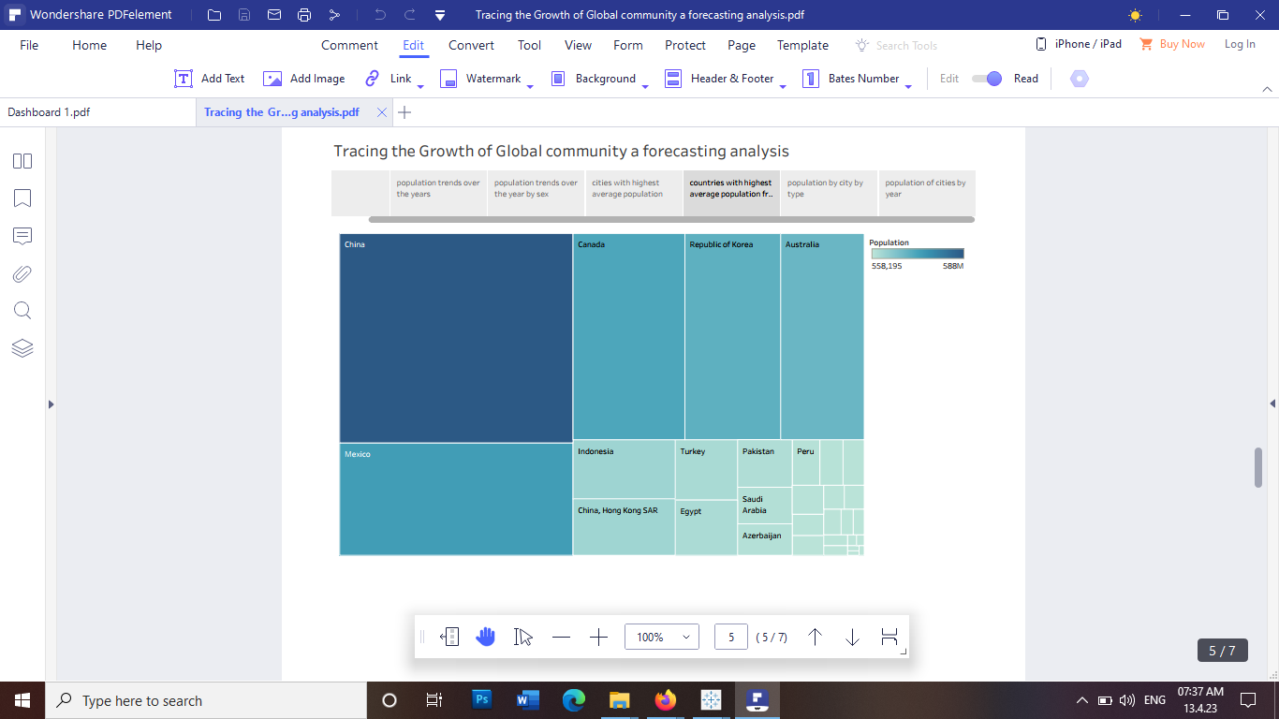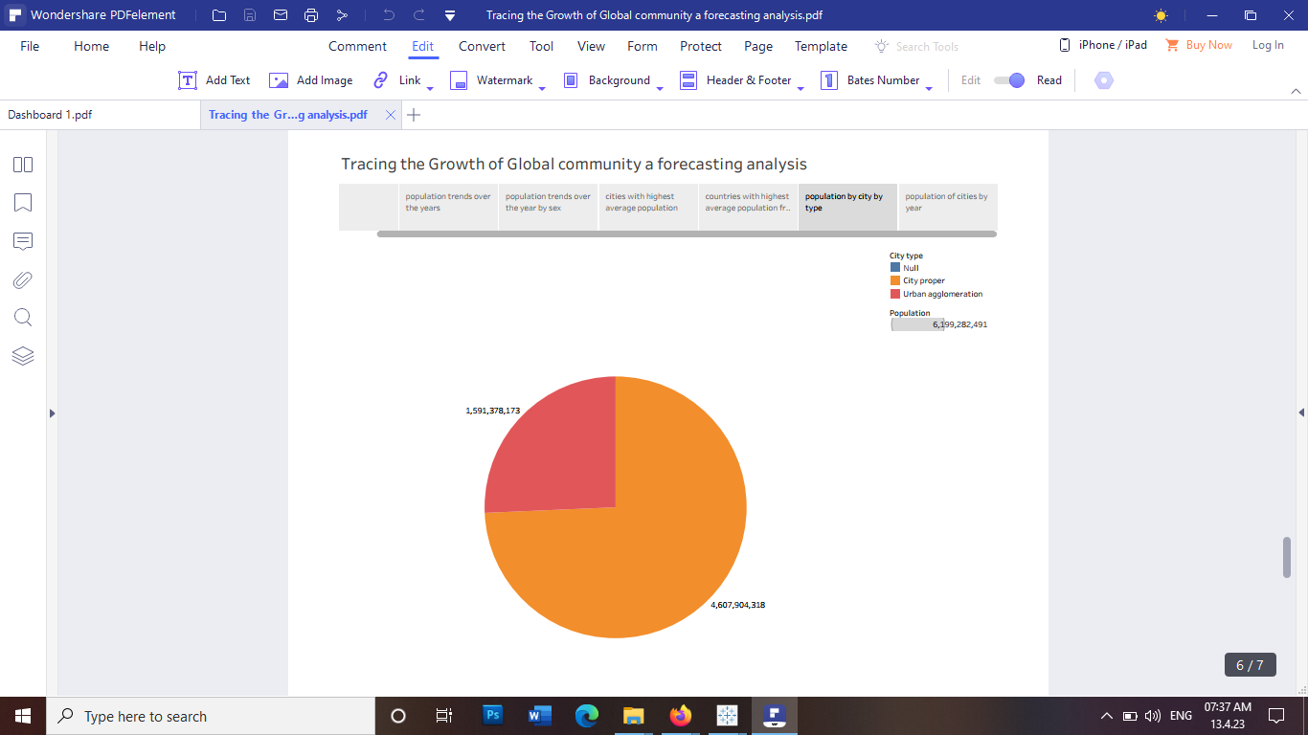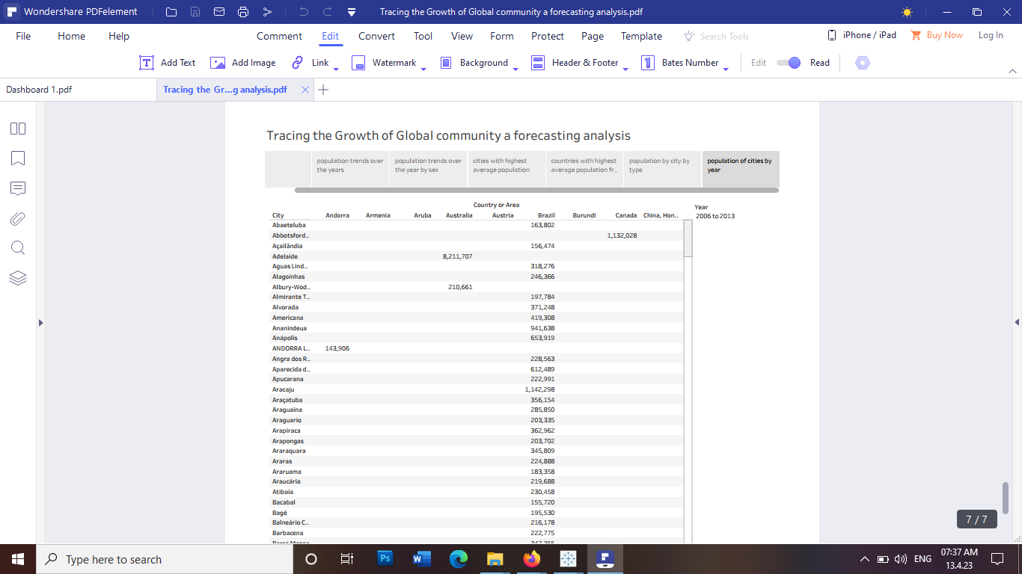

***Dash Board***

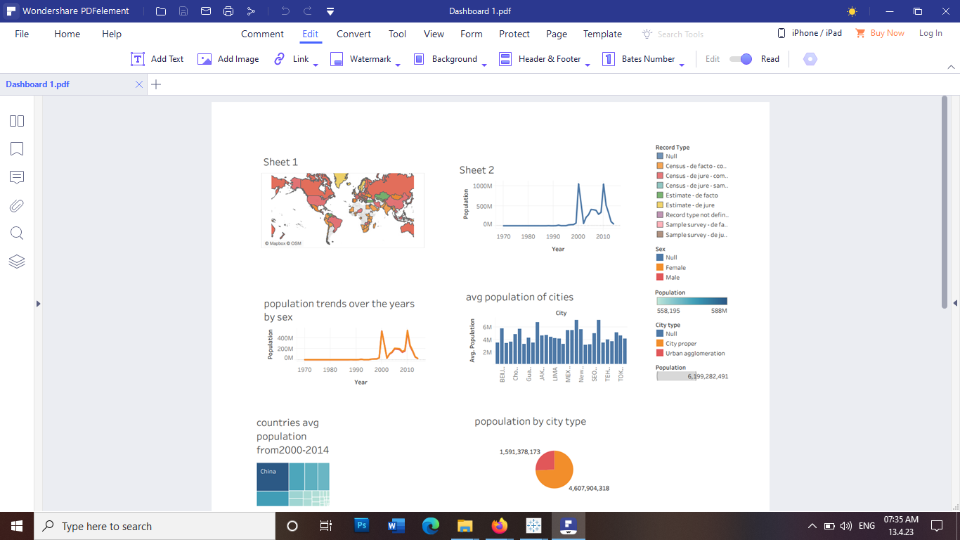

**Visualisation**

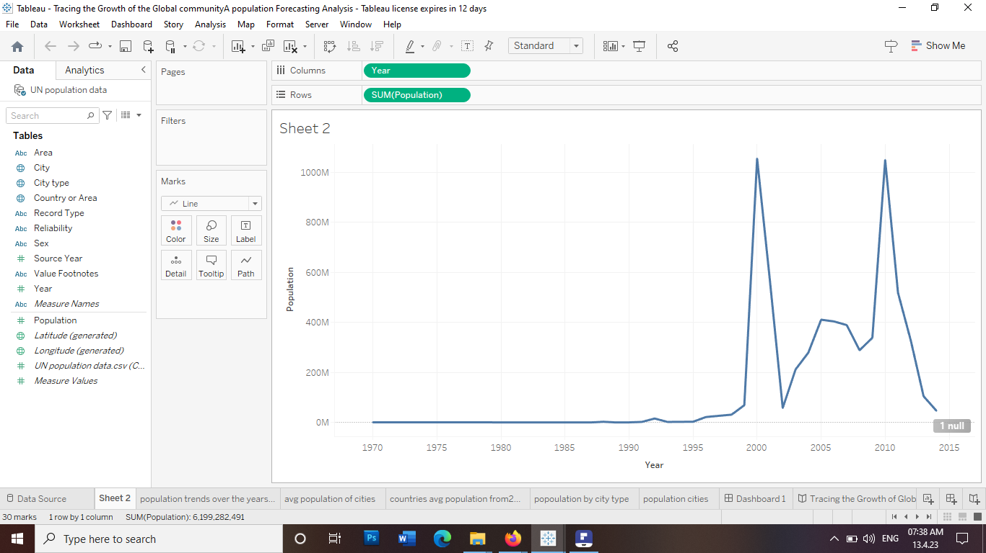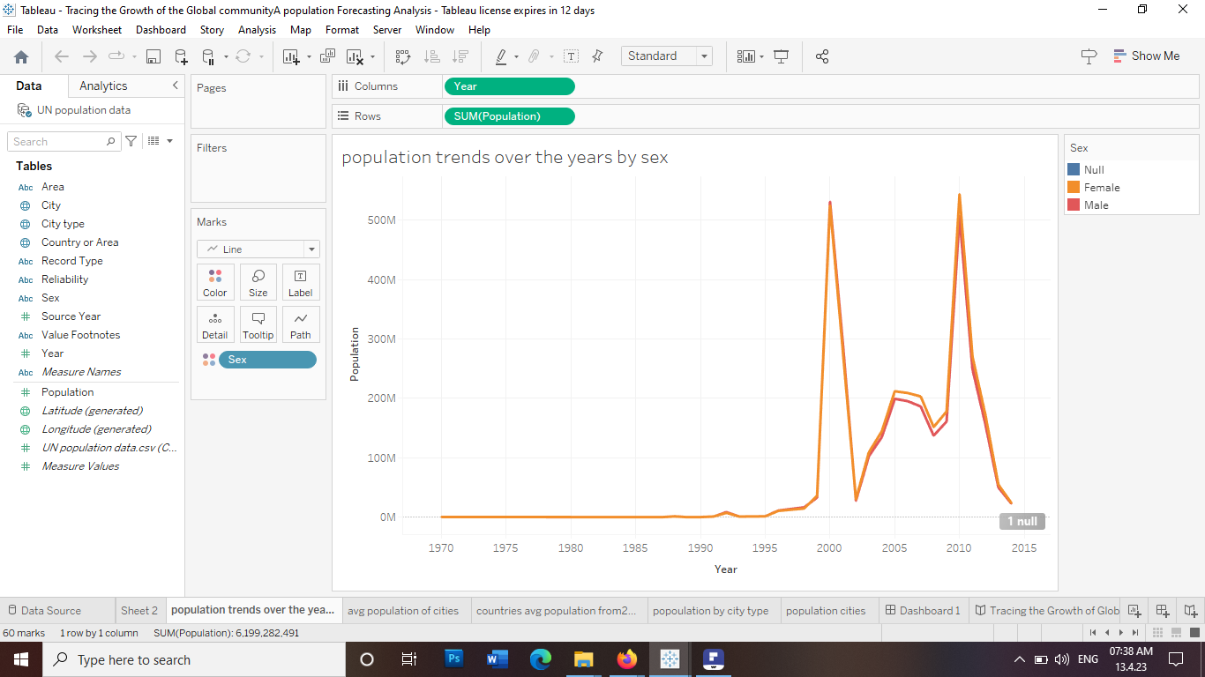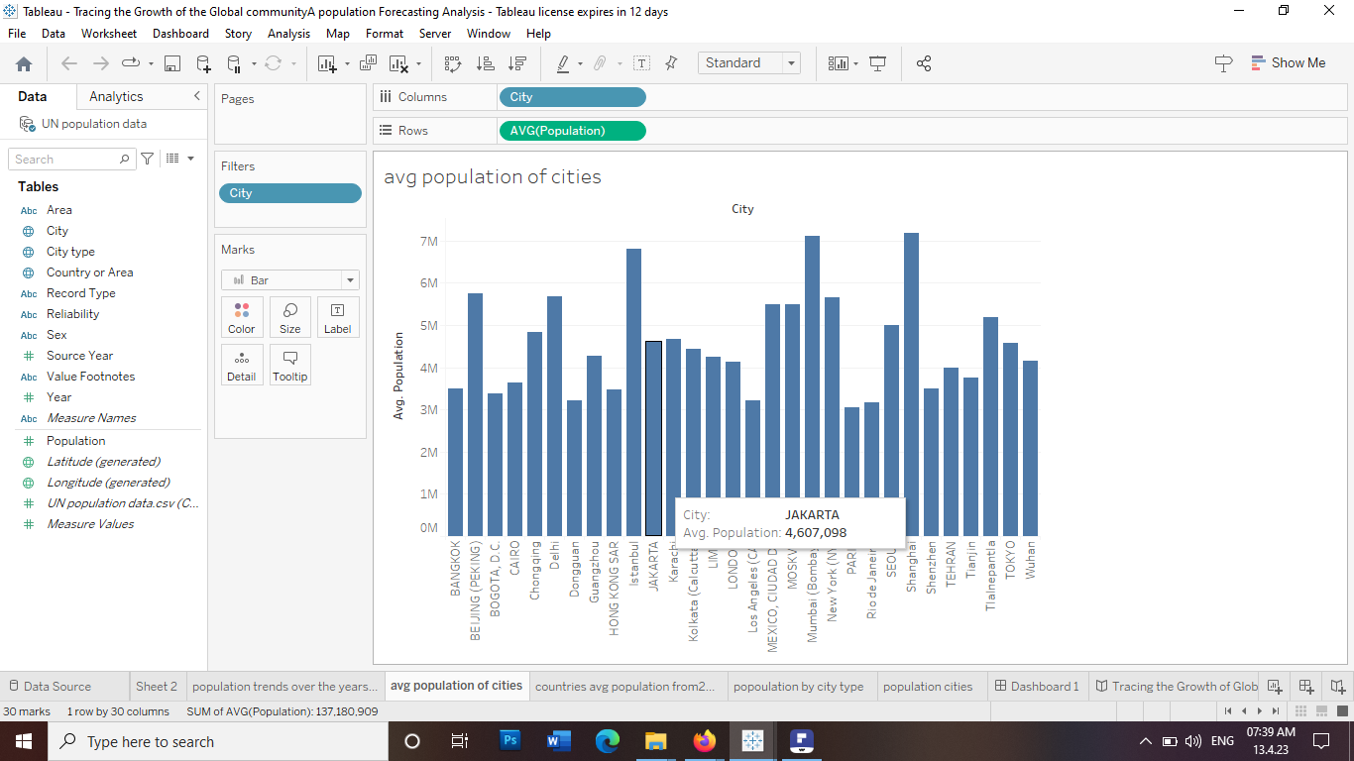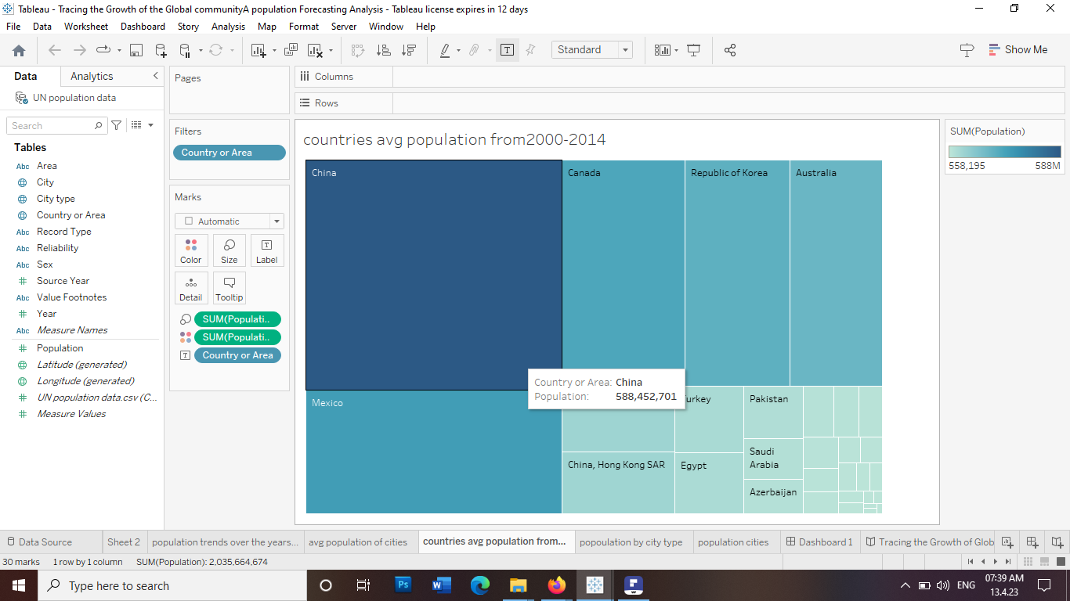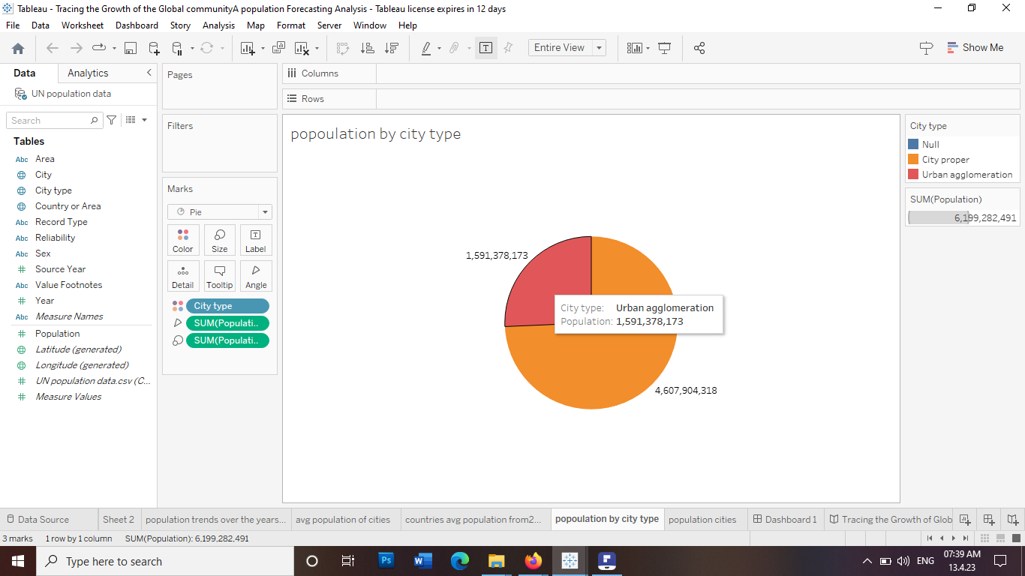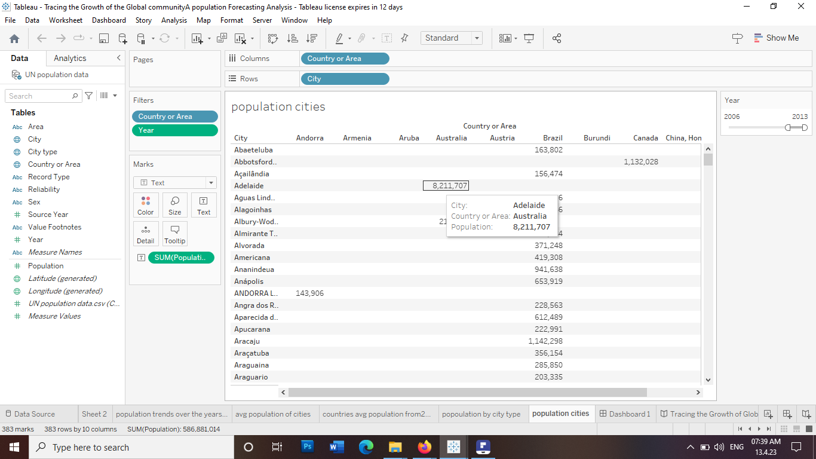

|  |  |  |
| --- | --- | --- |
|  | |  |
|  |

**Team Members**

Akash J.L

Aswin S.J Kumar

Ashmi S.R

Geevis Ajins.S

**Advantages and Disadvantages**

***Advantages***

Helps in planning for future needs: Population forecasting analysis can help governments, businesses, and organizations to plan for future needs in areas such as healthcare, education, housing, and transportation. By understanding population growth trends, decision-makers can develop strategies to address the needs of a growing population.  
  
Helps in making informed policy decisions: Population forecasting analysis can help policymakers to make informed decisions about issues such as immigration, family planning, and resource management. By understanding population growth trends, policymakers can anticipate future demands and develop policies to address these demands.  
  
Helps in identifying demographic changes: Population forecasting analysis can help in identifying demographic changes such as changes in birth rates, death rates, and migration patterns. This information can be used to understand the needs of specific population groups and to develop policies and programs to meet these needs.  
  
Helps in evaluating the impact of interventions: Population forecasting analysis can be used to evaluate the impact of interventions aimed at reducing population growth or addressing specific demographic changes. By measuring changes in population growth over time, decision-makers can evaluate the success of these interventions and make adjustments as needed.  
  
Provides a basis for research and analysis: Population forecasting analysis provides a basis for research and analysis in a wide range of fields such as sociology, economics, and public health. This information can be used to develop new theories, models, and policies related to population growth and demographic changes.

***Disadvantage***

Uncertainty: Population forecasting analysis relies on assumptions about future trends in fertility, mortality, and migration. These assumptions are subject to uncertainty, and even small variations in these factors can significantly affect the accuracy of the forecast.  
  
Data Limitations: Accurate population forecasting requires reliable data on fertility, mortality, and migration patterns, but these data are often limited, particularly in developing countries. Inaccurate or incomplete data can lead to incorrect forecasts.  
  
Inflexibility: Population forecasts are based on long-term trends and are therefore less adaptable to sudden changes or crises, such as pandemics, natural disasters, or conflicts.  
  
Social and economic factors: Population forecasting analysis may not fully account for complex social and economic factors that can impact population growth, such as changing cultural norms, changing economic conditions, or government policies.  
  
Ethical considerations: Population forecasting analysis can have significant social and ethical implications, such as implications for healthcare planning, education, and resource allocation. It is essential to consider these ethical issues when conducting population forecasting analysis.

|  |  |
| --- | --- |
|  |  |

**Application:**

|  |  |
| --- | --- |
|  |  |

To trace the growth of the global community and forecast population trends, you can use population forecasting models that incorporate various factors such as birth rates, death rates, immigration, and emigration. These models can help provide insights into future population growth, which can have significant implications for economic, social, and environmental development.  
  
There are several population forecasting models that you can use to analyze population growth. Some of the commonly used models include the cohort-component model, the exponential growth model, and the logistic growth model.  
  
The cohort-component model is a comprehensive population forecasting method that incorporates data on birth rates, death rates, and migration patterns. This model divides the population into age and gender cohorts, and then projects the future population based on the assumption that the fertility, mortality, and migration rates remain constant.  
  
The exponential growth model assumes that population growth occurs at a constant rate over time, without any limit on resources or other factors that could limit population growth. This model is useful for short-term population forecasting but may not accurately represent long-term trends.  
  
The logistic growth model is another commonly used method for population forecasting. It assumes that population growth follows a sigmoidal curve, which means that growth initially increases rapidly but eventually slows down as the population approaches its carrying capacity. This model is useful for long-term population forecasting but may require more data and assumptions than the other models.  
  
To analyze the growth of the global community and forecast population trends, you can use a combination of these models and incorporate data from various sources such as census data, demographic surveys, and migration statistics. By analyzing the trends in birth rates, death rates, and migration patterns, you can gain insights into the future growth of the global community and its implications for social, economic, and environmental development.

**Conclusion:**

Conclusion for tracing the growth of the global community; A population forecasting Analysis   
  
Tracing the growth of the global community through population forecasting analysis can provide valuable insights into the future trends and challenges of our world. Based on current demographic trends, it is projected that the global population will continue to increase in the coming decades, albeit at a slower pace than in the past.  
  
By 2050, the world's population is expected to reach 9.7 billion, with the greatest growth occurring in sub-Saharan Africa and parts of Asia. This population growth will put additional pressure on resources, infrastructure, and social systems, particularly in developing countries.  
  
In addition to population growth, aging populations in many parts of the world will create new challenges for healthcare, retirement systems, and labor markets. Urbanization will also continue to be a significant trend, with more people moving to cities and putting pressure on urban infrastructure and services.  
  
Overall, population forecasting analysis can provide important insights into the future challenges and opportunities of our global community. By understanding these trends and planning accordingly, we can work towards building a sustainable and prosperous future for all.

**Future Scope**

Population forecasting analysis has an important role to play in understanding the growth of the global community, and its future scope is vast. As the world's population continues to grow and evolve, population forecasting analysis can help us anticipate and prepare for changes in demographics, economics, and social systems.  
  
One area where population forecasting analysis can be particularly valuable is in informing policy decisions related to healthcare, education, and social welfare. By understanding population trends and projections, policymakers can make informed decisions about the allocation of resources and the design of social programs.  
  
Another important application of population forecasting analysis is in business planning and market research. Demographic trends can provide valuable insights into consumer behavior, preferences, and demand, which can help businesses plan their operations and marketing strategies accordingly.  
  
Population forecasting analysis can also play a critical role in addressing global challenges such as climate change, resource depletion, and social inequality. By understanding population trends and their impact on natural resources and social systems, we can develop more effective policies and strategies for sustainable development.  
  
Overall, the future scope of population forecasting analysis is vast and multifaceted, and it will continue to play an essential role in shaping the future of the global community